- Prepare a empty USB flash drive and format it to FAT32.
- Copy the “update” folder to the root directory of the USB drive.
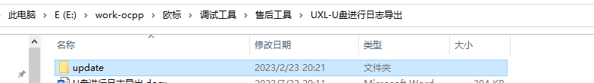
- Power on the charger, insert the USB drive into the USB1 port of the TCU.
- After 20 seconds, remove the USB drive.
- On the USB drive, go to /update/file/ and extract the compressed file named by timestamp.
